

Database Design for College Accommodation
Philip Hogan
22 January 2019

Database Design for College Accommodation
Introduction
The purpose of this report is to design a college accommodation database in line with the criteria set out in the by the college accommodation Director.

Students Table Description
This table will hold the student’s data. Each table row will be uniquely identified using the student’s number as a primary key. Student’s adviser internal telephone number will be included in this table as a foreign key.
Students Table Design
The design view of the student’s table with its attributes is as shown below.
Table 1: Student_table_ph
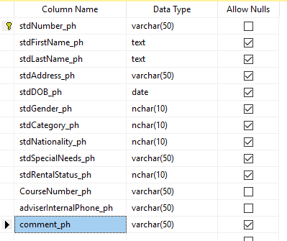
Students Sample Data
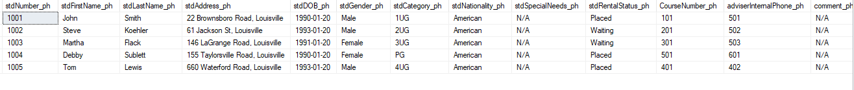
PUT KEY CHART IN HERE (DO SAME FOR ALL OTHER TABLES)

Adviser Table Description
This table will be created to hold adviser’s data. The primary key will be the adviser’s internal telephone.
Adviser Table Design
The design for adviser’s table is as shown below.
Table 2: Adviser_table_ph
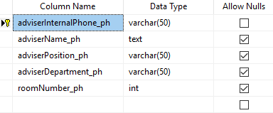
Advisers Sample Data
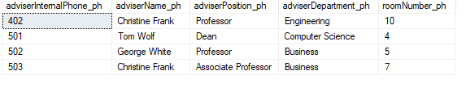

College-owned Residence Table Description
In this table, data about the students renting college-owned rooms will be stored. Place number as a primary key will be used to uniquely identify each row in the table. The student-number attribute will be added to this table as a foreign key.
College-owned Residence Table Design
Table 3: College_Rentals_ph
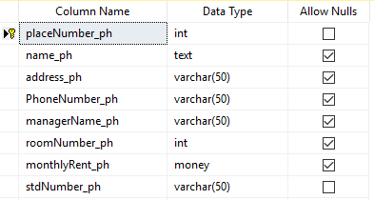
College-owned Residence Sample Data
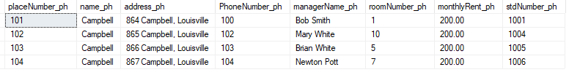

Private-Houses Table Description
Private houses table will store data about the private residence. House number will uniquely identify each row in this table. Student-number and place-numbers will be used as foreign keys.
Private-Houses Table Design
Table 4: Private_Houses_ph
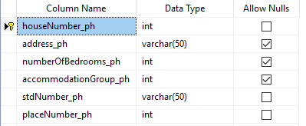
Private-Houses Sample Data
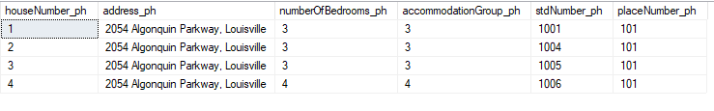

Private-Rentals Table Description
This table will store private rooms data. Place-number will be used to uniquely identify each row in the table.
Private-Rooms Table Design
Table 5: Private_Rooms_ph
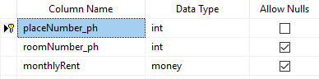
Private-Rooms Sample Data
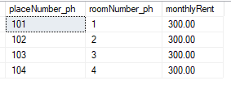

Lease Agreement Table Description
The lease agreement table keeps track of rental records for all students to ensure proper management of the rentals.
Lease Agreement Table Design
Table 6: Lease_agreement_ph
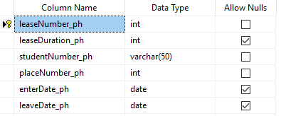
Lease Agreement Sample Data
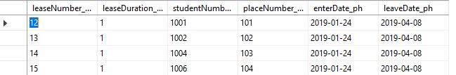

Private House Inspection Table Description
The inspection table will ensure that data concerning the staff member inspecting the rentals and rooms conditions are managed properly.
Private House Inspection Table Design
Table 7: Private_House_Inspection_ph
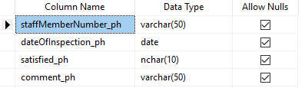
Private House Inspection Sample Data
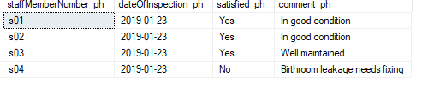

Member of Staff Table Description
Member of staff table will store data about staff members. This will make it possible to keep track and manage employees’ responsibilities.
Member of Staff Table Design
Table 8: Staff_members_ph
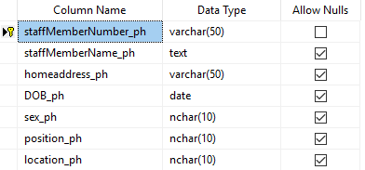
Member of Staff Sample Data
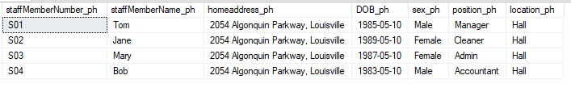

Course Table Description
In this table, student’s courses will be stored. Course-number is the primary key that uniquely identifies every row in this table.
Course Table Design
Table 9: Courses_ph
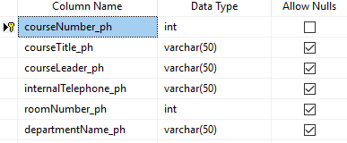
Courses Sample Data
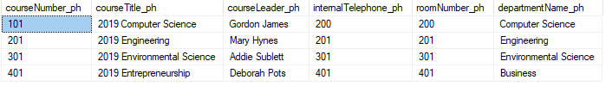

Student’s Next-of-Kin Table Description
This table will capture data about student’s next-of-kin to be used for emergency purposes.
Student’s Next-of-Kin Table Design
Table 10: Next_of_kin_ph
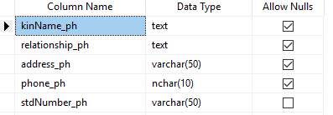
Student’s Next-of-Kin Sample Data
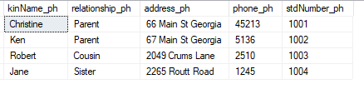

References
Thomas, M. C., Carolyn, E. B. (2002). A Practical Approach to Design, Implementation, and Management. Database Systems, 6, 406-413.

